Unit 6 – Chemical Calculations Notes

Introduction

How do manufacturers know how to make enough of their desired products?
Watch the following videos:
“How Do Airbags Work” https://www.youtube.com/watch?v=ysGS-_6E80s

“How far can an Airbag Launch a Football?” https://www.youtube.com/watch?v=fgLfhInA6-c
What can happen if they use too much starting material (reactants)?
What can happen if they use to little starting material (reactants)?
Learning Target:
I will be able to:

Stoichiometry – Chemical Calculations
mole ratio:

In chemical calculations, are used to convert between a to .
Look at the balanced equation for production of ammonia:
N₂(g) + 3H₂(g) → 2NH₃(g)
Three different mole ratios can be derived from this balanced equation.

___________ ___________ ___________

Mole to Mole Calculations
In the mole ratio below, W is the , wanted quantity and G is the .
The values of a and b are the from the .
The general solution for a mole-mole problem is given by:
x =

Calculating Moles of a Product
Problem: How many moles of NH₃ are produced when 0.60 mol of nitrogen reacts with hydrogen?
N₂(g) + 3H₂(g) → 2NH₃(g)
x =
Mass-Mass Calculations
In the laboratory the is usually determined by .
If we know the of a reactant or product, then the mass of .
If a given sample ( ) is measured in grams, it can be by using the .
The from the can be used to calculate the .
If it is the that needs to be determined, the number of moles of the unknown can be .
Steps for Solving a Mass-Mass Problem
Change the mass of G to moles of G (mass G → mol G) by using the molar mass of G.
x =

Change the moles of G to moles of W (mol G → mol W ) by using the mole ratio from the balanced equation.
x =

Change the moles of W to grams of W (mol W → mass W ) by using the molar mass of W.
x =

Another way to represent the steps for doing mole-mass and mass-mole stoichiometric calculations is shown here:
For a problem, the first conversion is skipped.
For a problem, the last conversion is skipped.

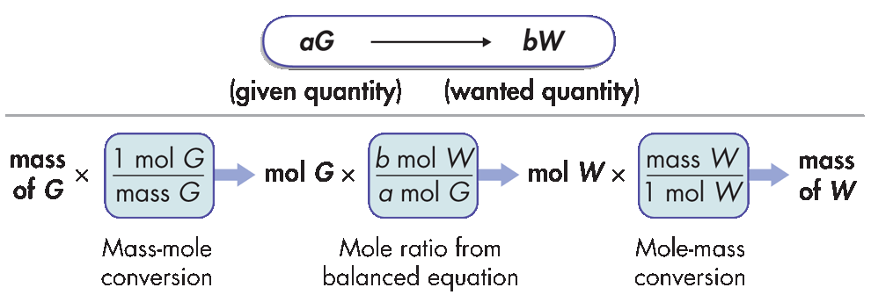

Calculating the Mass of a Product
Calculate the number of grams of NH₃ produced by the reaction of 5.40 g of hydrogen with an excess of nitrogen. The balanced equation is:
N₂(g) + 3H₂(g) → 2NH₃(g)

x x x =

given quantity change given unit to moles mole ratio change moles to grams

Other Stoichiometric Calculations
In a typical stoichiometric problem:
- The given quantity is .
- Then, the is used to calculate the .
- Finally, the moles are converted to related to the unit mole, .
The mole-mass relationship gives you two conversion factors.

and

Summary of steps for typical stoichiometric problems:
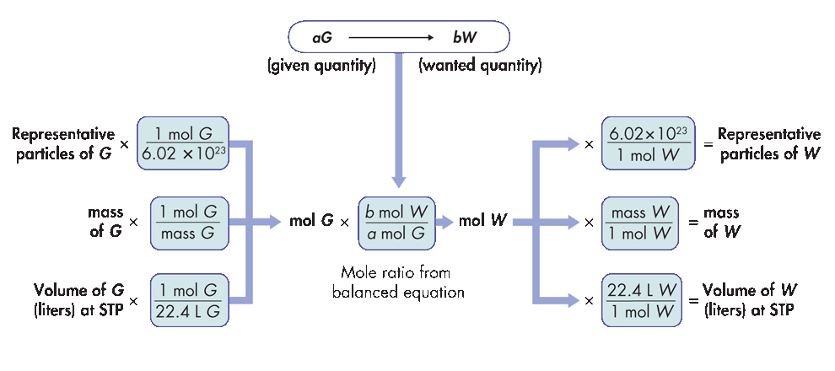
How many molecules of oxygen are produced when 29.2 g of H₂O is decomposed by electrolysis?
2H₂O 2H₂ + O₂

x x x =

Volume to Volume Calculations
and combine to form the brown gas , which contributes to .
How many liters of nitrogen dioxide are produced when 34 L of oxygen react with an excess of nitrogen monoxide? Assume conditions are at STP.
2NO(g) + O₂(g) → 2NO₂(g)

x x x =
The Mole and Quantifying Matter
from the balanced equation are used to calculate the amount of a in a chemical reaction from a given amount of .
Stoichiometry – Chemical Calculations
Determining the amount of chemicals needed to create a specific volume of a gas for an air bag:

