

**Paradise Honors High School**

**Class Supply List**

**Mr. Peapenburg – B128**

**Anatomy & Physiology**

**Earth & Space Science**

## COURSE MATERIALS

Please bring the following with you to class every day:

1. Universal Supplies listed on the PHHS Website
2. Headphones/earbuds (optional, your teacher will not have a class set)
3. 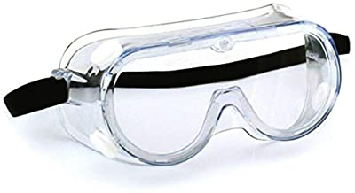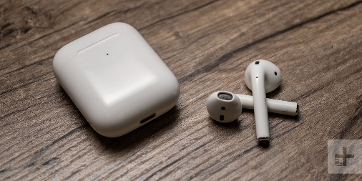Safety Goggles (optional, your teacher has a class set)