**Electron Configurations**

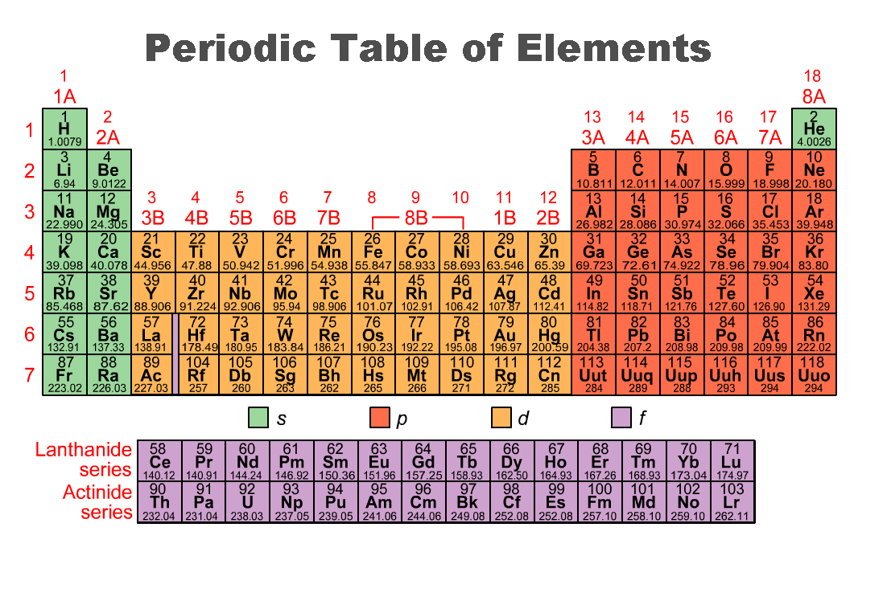

1s

1s

2s

3s

4s

5s

6s

7s

3d

4d

5d

6d

3p

5p

6p

7p

4f

5f

1

2

3

4

5

6

7

6

7

4p

2p