**Electron Configuration Diagrams**

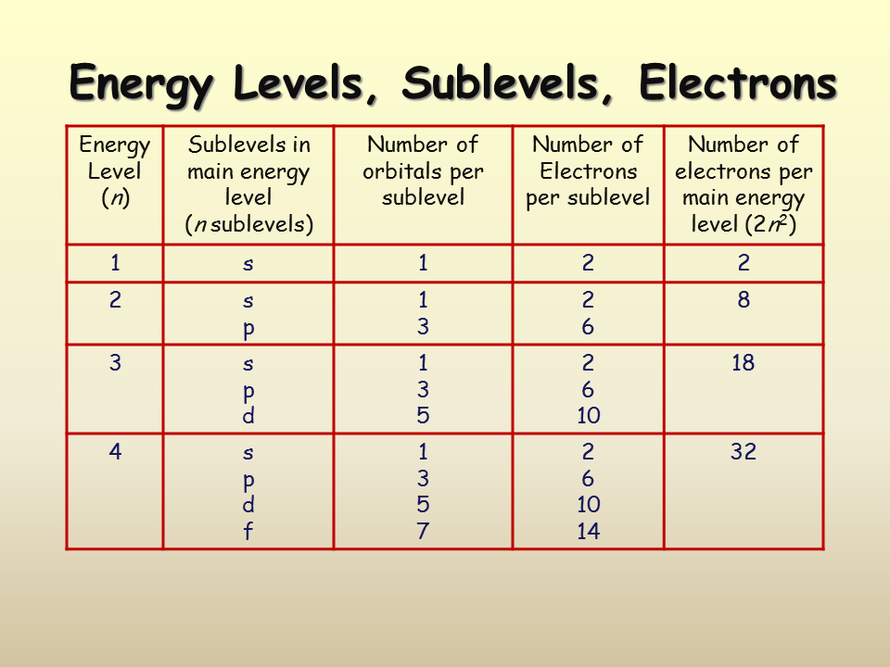

**aufbau Principle**

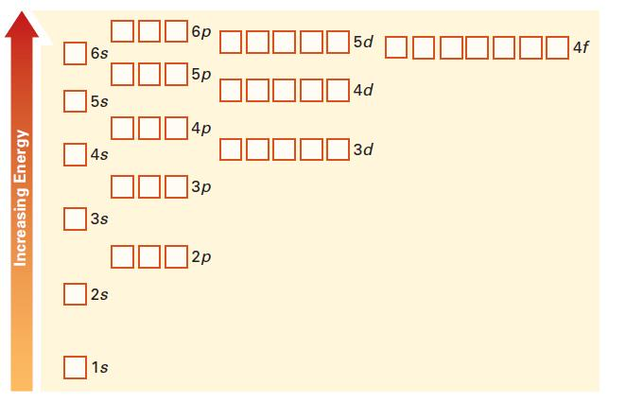

Electrons fill the lowest energy orbitals first.

**Hund’s Rule**

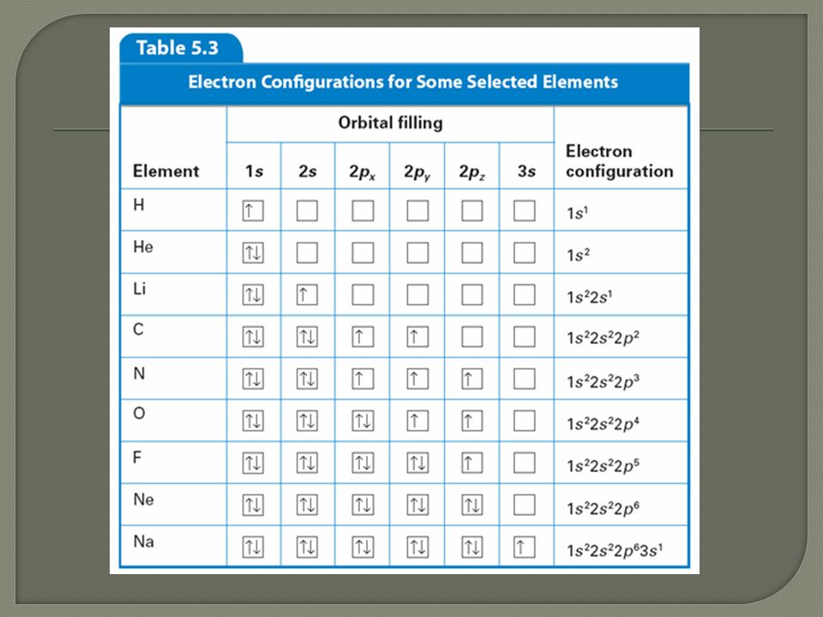

**Filling Electron Configurations**

