General Chemistry Unit 1
Scientific Method Notes

Objectives  History in Science  Scientific Method  The Depth Of Knowledge Levels  Closure | I will be able to:  - name the steps of the Scientific Method.  - describe each step of the Scientific Method.  - By the 1500s in Europe, there was a shift from alchemy to science. Science flourished in Britain in the 1600s, partly because King Charles II was a supporter of the sciences. With his permission, some scientists formed the Royal Society of London for the Promotion of Natural Knowledge. The scientists met to discuss scientific topics and conduct experiments.  - The society’s aim was to encourage scientists to base their conclusions about the natural world on experimental evidence, not on philosophical debates.  - In France, Antoine-Laurent Lavoisier did work in the late 1700s that would revolutionize the science of chemistry.  - Lavoisier helped to transform chemistry from a science of observation to the science of measurement that it is today.  - To make careful measurements, Lavoisier designed a balance that could measure mass to the nearest 0.0005 gram.  - At the time of the French Revolution, Lavoisier was a member of the despised royal taxation commission. He took the position to finance his scientific work. Although he was dedicated to improving the lives of the common people, his association with taxation made him a target of the revolution. In 1794 he was arrested, tried, and beheaded.  Scientific Method: A series of problem–solving procedures that help scientists conduct experiments.  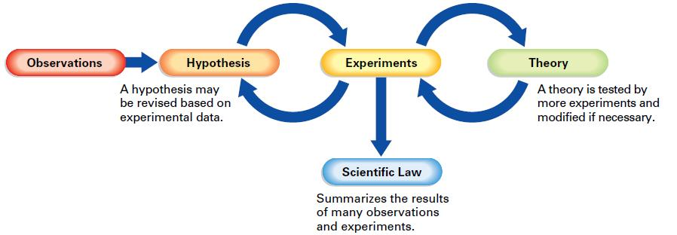  Getting to the first waypoint (Observations):  - Step 1: Use your senses to obtain information.  - Step 2: Does this lead to a question?  Getting to the second waypoint (Hypothesis):  - Step 1: Define a problem/subject to study from your observations.  - Step 2: Acquire background information.  - Step 3: Form a hypothesis.  hypothesis: a testable explanation of a situation that can be supported or disproved by careful procedures.  - When the experimental data does not fit a hypothesis, the hypothesis must be changed.  Getting to the third waypoint (Experiments):  - Step 1: Design a procedure that is used to test your hypothesis.  - Your design should include variables (factors that can change)  - Dependent variable (responding)  - Independent variable (manipulated)  - For the hypothesis to be accepted, the experiment must produce the same results no matter who or how many times it is repeated.  Getting to the fourth waypoint (Theory):  - Step 1: This is a hypothesis that meets the test of repeated experimentation.  - Textbook definition: a well-tested explanation for a broad set of observations.  - Step 2: Theories for science are not proven!  - We need to leave open the possibility that a theory may need to be changed at some point in the future to explain new observations or experimental results.  Getting to the last waypoint (Scientific Law):  - Textbook definition: a concise statement that summarizes the results of many observations and experiments.  - Basically a super-theory summary!  - Does not try to explain the relationship simply states the relationship.  - i.e. gas laws  Key idea to the scientific method!  - The scientific method(s) are not rigid, step-by-step outlines to solve problems.  - The important concept is that systematic investigation is integral in any intellectual pursuit.  - You have to be able to tell me why you believe what you believe and why it is really real…  Level 1: Recall  - This level involves basic tasks that require recall of facts or rote reproduction of simple procedures. These kinds of tasks do not require any cognitive effort beyond remembering the right response or formula.  Level 2: Skills and Concepts  - This level requires a student to make some decisions about problem solving and procedures. DOK 2 tasks may involve applying a skill in a new context or explaining thinking in terms of concepts.  Level 3: Strategic Thinking  - This level gets more complex and abstract. Students must use reasoning, planning, and evidence to explain their thought processes. Often, Level 3 tasks have more than one valid response, and students must justify their choices.  Level 4: Extended Thinking  - Level 4 tasks are at least as complex as level 3 tasks but require an extended time period—several weeks, perhaps, or even longer—to complete.  - Explore how the scientific method relates to another topic/idea you are currently studying in another course. Write a paragraph that describes the connection in detail. Then in another paragraph explain why the scientific method is important.

