**Stoichiometric Calculations**

Starting/Given Value =

Ending/Wanted Value =

C

**Summary of Steps**

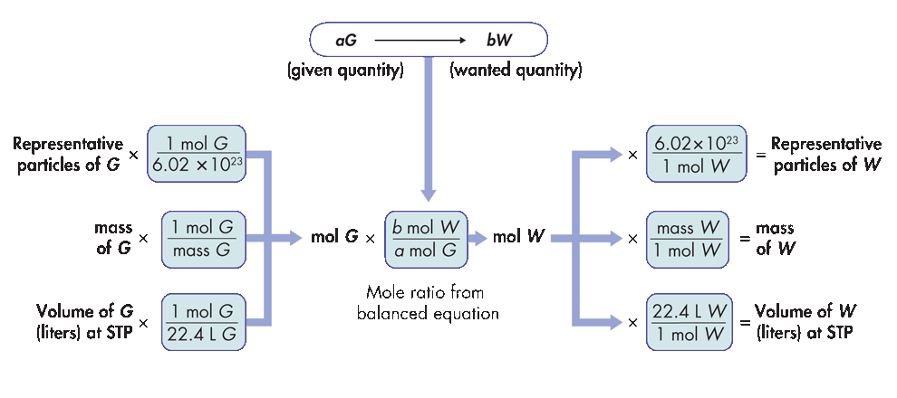

C

C

C

🡑

Given

Quantity

🡑

Conversion

Factor

🡑

**Mole Ratio from**

**Balanced Equation**

🡑

Conversion

Factor

🡑

Wanted

Quantity